Evan, Finn, and Atlantia
The impacts of developments on predator-prey cycles
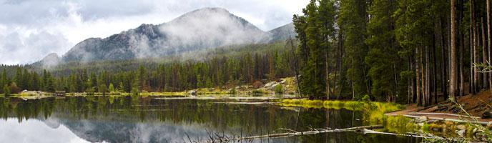
A maze of evergreen trees covers the mountainside in the subalpine areas. The subalpine forests elevations is just below tree line at 9,000ft and 11,400 feet. Usually subalpine forest are made up of subalpine fir, engelmann spruce, and quaking aspen. The creatures that live in subalpine forest are lynx, mountain goat, and yellow-bellied marmots. Abiotic factors is a nonliving factor or thing, biotic factors are living things that can affect the environment. There are several habitats that are affected by abiotic and biotic factors such as Wolf Creek in Pagosa Springs, Colorado. Wolf Creek is known for their ski area, and building development. There are several abiotic and biotic factors that affect Wolf Creek some of the main ones are, adding more buildings to the Wolf Creek Village, adding chemicals that were not present before, and rerouting water ways. There are many biotic factors but the ones that affect the lynx, the most, would be the downsizing of the snowshoe hare population, and the vegetation dropping. It is important for us to understand the role that people and predators play in maintaining the balance of this ecosystem and how the animal populations are affected when that balance is disrupted. To help us understand we need to answer the question, what role do the abiotic and biotic factors have in the decrease of the snowshoe hare population and how does that affect the lynx population in Southwest Colorado?

Research and Data:

Lynx Survival Diet
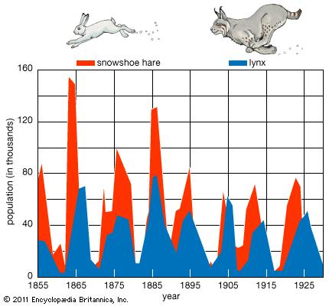Figure 1
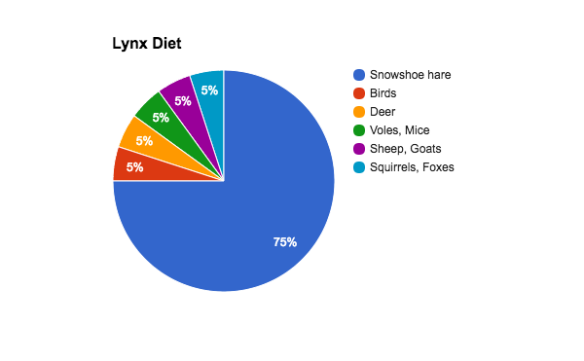Figure 2

In Figure 1, it shows the most recent research done on lynx and snowshoe hare densities in Southwest Colorado. The graph can show you that over every five years the snowshoe hare and lynx densities builds up and then drops greatly. Another thing that can be seen is that the lynx population follows the snowshoe hare population. The change in the two animals densities is known as predation which is the relationship between two things where one of them preys off the other. In the graph it is the lynx that is preying on the snowshoe hare to stay populated. The significance of this graph is the the lynx is highly dependable on the snowshoe hare population to stay high. This is concerning because if the lynx population were to go away entirely the snowshoe hare would over populate the area. If the area was overpopulated with snowshoe hares most would die from malnutrition and the lack in shelter. This shows that it is important to keep a strong lynx population in Southwest Colorado because it will keep two animals existing in Southwest Colorado.

Determine Possible Solutions:

Looking at the data that has been gathered from our research a possible solutions is:
- A possible solution would be to keep the population of lynx growing not have any development in lynx habitat (Wolf Creek Pass). If the hares are pushed out of lynx habitat due to development and trail fragmentation then the lynx population would shrink. Trail fragmentation is when a trail for hiking, mountain biking or skiing contribute to the degradation of the ecosystem. Lynx need a very specific habitat, they need a high elevation area with a large snowpack like Wolf Creek pass and that high snowpack and high elevation brings skiing and mountain biking that causes trail fragmentation.
The data that was collected all repeats that a large development of wolf creek would be a huge threat to the small canadian lynx population in colorado. As of now Lynx remain in a good habitat at population densities sufficient for breeding. The reintroduced lynx successfully reproduce and Lynx born in Colorado survive and also successfully reproduce. Also with climate change reducing snowpack in western North American mountains and shifting distribution of forests northward and up mountain slopes, high elevation linkage zones including Wolf Creek Pass will gain increasing importance as climate change alters the geographic location and distribution of lynx habitat. The growing importance of wolf creek pass makes it even more important that a potential development of wolf creek does not happen.

Sources:
http://www.durangonaturestudies.org/articles/121204.htm
http://cpw.state.co.us/learn/Pages/SOC-LynxResearch.aspx
https://www.durangoutdoors.com/wildlife/
https://www.britannica.com/animal/lynx-mammal

